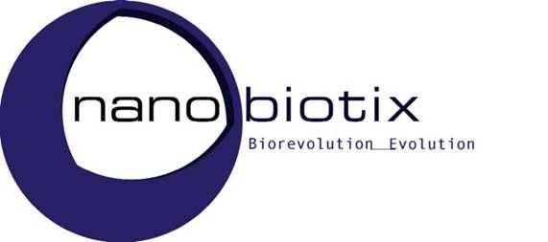

Expected and Unexpected Side Effects of Nanodrugs
Dr. Laurent Lévy, CEO of Nanobiotix, and Co-President of the French Technology Platform on
Nanomedicine (FTPN), Paris (F)
Nanotechnology offers revolutionary strategies to improve healthcare. Adequate nanomaterial characterization constitutes the basis to establish relevant programs of nanoparticle/biological systems cross talk evaluation. Also, the surrounding conditions significantly impact on the state of the nanoparticles in terms of their collective behavior: dispersion, aggregation, and stability in gas or liquid.
The “principle of designing” specific products is the paradigm of the nanomedecine. It is really new and it represents an essential point since creating innovative products should be supported by a previous risk evaluation based on the nanoscale chemistry. Furthermore, size does matter. Thus, both, size and chemistry of nanoparticles are probably the fundamental parameters from which all others depend on, and ultimately nanomaterial surface. And surfaces are the key players when considering safety.
In the field of the nanomedecine, the concept of expected/unexpected toxicity should be considered as for any healthcare product, from the perspectives of both, what might be anticipated from the chemical and pharmacological properties of a medicinal product, and what is the knowledge on events in terms of previous observation or documentation. Thus, as stated in the definition of the International Conference on Harmonisation (E2A-II.A.3.) an "unexpected" adverse reaction is one, the nature or severity of which is not consistent with already available information (in the relevant source document/s)”.
In contrast to the long history of classical drugs, the study of nanomaterial toxicology is being a little retarded due to the scarcity of ambitious safety assessments performed taking into account well defined axial chemistry. Here, the focus is made on hard nanoparticles which represent nanotherapeutics by themselves and not used as carriers.
In general, gold, iron oxide and hafnium oxide potential toxicity are discussed basically from the point of view of expectedness. It is generally admitted that these nanoparticles are biocompatible. Three features are to be highlighted:
- The specific chemistry of metal cations determines the final structures of crystals. Therefore, potential toxicity of any type of nanoparticle should definitively consider surfaces and properties such as catalysis of gold, dissolution of the iron oxide and the inert nature of the hafnium oxide.
- Spatial and temporal controlled effects of injectable nanoparticles, which can lower the overall systemic dose and damage that these products would otherwise produce. Temporally controlling the activity window of a product can also help decrease unwanted side effects that might otherwise occur with naturally active pharmacology.
- Differential involvement of cellular machineries for membrane binding, uptake and cellular distribution systems: all these parameters highly impact interactions with the mononuclear phagocytic cells.

Nanomedecine is based on selection of nanomaterials and thus, it has allowed “Choosing” instead “Screening” of products intended for human use

